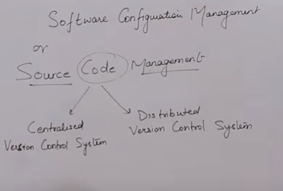

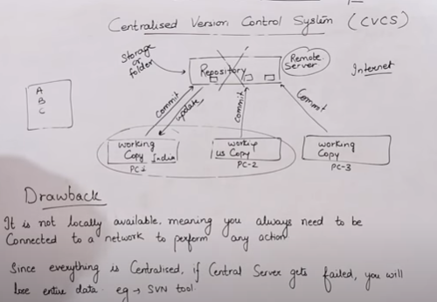

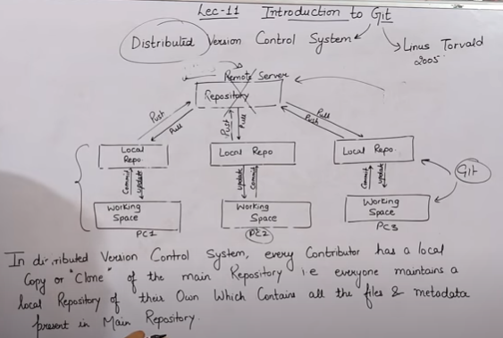

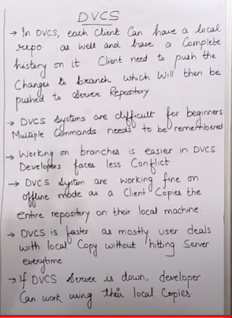

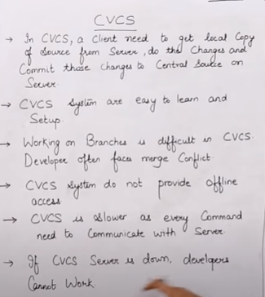

Git Reset:

----------

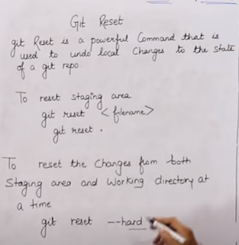

Delete from only staging area

Ranjan@DESKTOP-K87NR6R MINGW64 ~/git-test (master)

$ cat > testfile

for reset from stasging area

Ranjan@DESKTOP-K87NR6R MINGW64 ~/git-test (master)

$ git add .

warning: LF will be replaced by CRLF in testfile.

The file will have its original line endings in your working directory.

Ranjan@DESKTOP-K87NR6R MINGW64 ~/git-test (master)

$ git status

On branch master

Changes to be committed:

(use "git reset HEAD <file>..." to unstage)

new file: testfile

Ranjan@DESKTOP-K87NR6R MINGW64 ~/git-test (master)

$ git reset .

Ranjan@DESKTOP-K87NR6R MINGW64 ~/git-test (master)

$ git status

On branch master

Untracked files:

(use "git add <file>..." to include in what will be committed)

testfile

nothing added to commit but untracked files present (use "git add" to track)

Ranjan@DESKTOP-K87NR6R MINGW64 ~/git-test (master)

Below command delete from working & stagging srea

Ranjan@DESKTOP-K87NR6R MINGW64 ~/git-test (master)

$ git add .

warning: LF will be replaced by CRLF in testfile.

The file will have its original line endings in your working directory.

Ranjan@DESKTOP-K87NR6R MINGW64 ~/git-test (master)

$ git status

On branch master

Changes to be committed:

(use "git reset HEAD <file>..." to unstage)

new file: testfile

Ranjan@DESKTOP-K87NR6R MINGW64 ~/git-test (master)

$ git reset --hard

HEAD is now at eb2b4cd second code done

Ranjan@DESKTOP-K87NR6R MINGW64 ~/git-test (master)

$ git status

On branch master

nothing to commit, working tree clean

Ranjan@DESKTOP-K87NR6R MINGW64 ~/git-test (master)

Git Revert:

In revert don’t delete the file only omit the previous commit (already committed) and set it back to the final commit

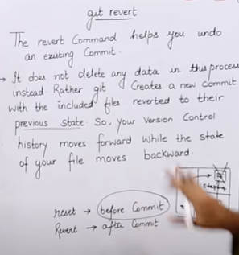

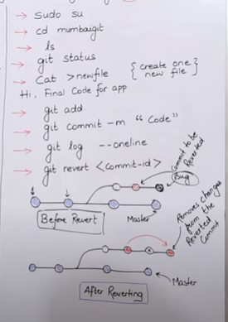

Ranjan@DESKTOP-K87NR6R MINGW64 ~/git-test (master)

$ cat > revertfile

add first line

add second line

Ranjan@DESKTOP-K87NR6R MINGW64 ~/git-test (master)

$ git add .

warning: LF will be replaced by CRLF in revertfile.

The file will have its original line endings in your working directory.

Ranjan@DESKTOP-K87NR6R MINGW64 ~/git-test (master)

$ git commit -m "added 2 lines for revert"

[master 28c4a2d] added 2 lines for revert

1 file changed, 2 insertions(+)

create mode 100644 revertfile

Ranjan@DESKTOP-K87NR6R MINGW64 ~/git-test (master)

$ cat revertfile

add first line

add second line

Ranjan@DESKTOP-K87NR6R MINGW64 ~/git-test (master)

$ cat >> revertfile

Dont want add 3rd line

Ranjan@DESKTOP-K87NR6R MINGW64 ~/git-test (master)

$ git add .

warning: LF will be replaced by CRLF in revertfile.

The file will have its original line endings in your working directory.

Ranjan@DESKTOP-K87NR6R MINGW64 ~/git-test (master)

$ git commit -m "Add unwanted file"

[master ce3099f] Add unwanted file

1 file changed, 1 insertion(+), 2 deletions(-)

Ranjan@DESKTOP-K87NR6R MINGW64 ~/git-test (master)

$ git log

commit ce3099fa871623a3b681e6cb2e73db162d391249

Author: hello <hellobangalore.com>

Date: Thu Nov 5 13:11:43 2020 +0530

Add unwanted file

commit 28c4a2d64ccd2e632ebdb618b7708cae60da51a8

Author: hello <hellobangalore.com>

Date: Thu Nov 5 13:09:20 2020 +0530

added 2 lines for revert

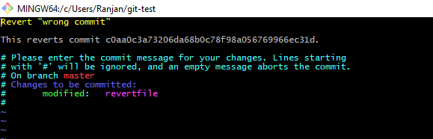

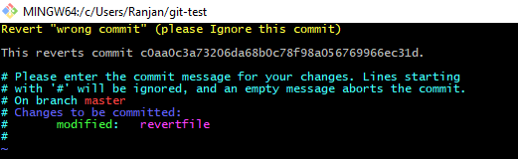

Ranjan@DESKTOP-K87NR6R MINGW64 ~/git-test (master)

$ git revert c0aa0c3a73206da68b0c78f98a056769966ec31d

[master 39bb03e] Revert "wrong commit" (please Ignore this commit)

1 file changed, 2 deletions(-)

Ranjan@DESKTOP-K87NR6R MINGW64 ~/git-test (master)

$ ls

abc1 demof1 election ght revertfile

Ranjan@DESKTOP-K87NR6R MINGW64 ~/git-test (master)

$ cat revertfile

Dont want add 3rd line

Ranjan@DESKTOP-K87NR6R MINGW64 ~/git-test (master)

$ git log --oneline

39bb03e Revert "wrong commit" (please Ignore this commit)

c0aa0c3 wrong commit

ce3099f Add unwanted file

28c4a2d added 2 lines for revert

How to Remove Untracked Files

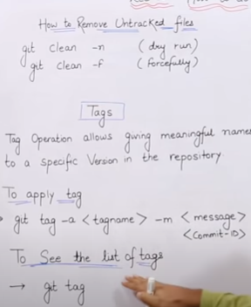

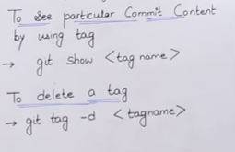

Taging

Ranjan@DESKTOP-K87NR6R MINGW64 ~/git-test (master)

$ git log --oneline

39bb03e Revert "wrong commit" (please Ignore this commit)

c0aa0c3 wrong commit

ce3099f Add unwanted file

28c4a2d added 2 lines for revert

eb2b4cd second code done

e4953aa Initial code done

92c24da demo file for stashing

3a8b9a3 resolve conflict

3fb03b4 trd commit with new conflict msg

177ca7d third commit with merge conflict

6850c8c 2nd commit

8366252 1st commit

Ranjan@DESKTOP-K87NR6R MINGW64 ~/git-test (master)

$ git tag -a important -m "this is very imp commit" 6850c8c

Ranjan@DESKTOP-K87NR6R MINGW64 ~/git-test (master)

$ git tag

important

Ranjan@DESKTOP-K87NR6R MINGW64 ~/git-test (master)

$ git show important

tag important

Tagger: hello <hellobangalore.com>

Date: Thu Nov 5 13:37:29 2020 +0530

this is very imp commit

commit 6850c8ccaf6fd01f027ed27e3a86458f0323ed79

Author: hello <hellobangalore.com>

Date: Thu Nov 5 01:44:54 2020 +0530

2nd commit

**diff --git a/ght b/ght**

**new file mode 100644**

**index 0000000..f471c09**

**--- /dev/null**

**+++ b/ght**

@@ -0,0 +1,2 @@

+hi

+hello

Ranjan@DESKTOP-K87NR6R MINGW64 ~/git-test (master)

$ git tag -d important

Deleted tag 'important' (was 3e932d5)

Ranjan@DESKTOP-K87NR6R MINGW64 ~/git-test (master)

$ git tag

Untrack file Delete

Ranjan@DESKTOP-K87NR6R MINGW64 ~/git-test (master)

$ touch aaa and fre ghr

Ranjan@DESKTOP-K87NR6R MINGW64 ~/git-test (master)

$ ls

aaa abc1 and demof1 election fre ghr ght revertfile

Ranjan@DESKTOP-K87NR6R MINGW64 ~/git-test (master)

$ git status

On branch master

Untracked files:

(use "git add <file>..." to include in what will be committed)

aaa

and

fre

ghr

nothing added to commit but untracked files present (use "git add" to track)

Ranjan@DESKTOP-K87NR6R MINGW64 ~/git-test (master)

$ git clean -n

Would remove aaa

Would remove and

Would remove fre

Would remove ghr

Ranjan@DESKTOP-K87NR6R MINGW64 ~/git-test (master)

$ git status

On branch master

Untracked files:

(use "git add <file>..." to include in what will be committed)

aaa

and

fre

ghr

nothing added to commit but untracked files present (use "git add" to track)

Ranjan@DESKTOP-K87NR6R MINGW64 ~/git-test (master)

$ git clean -f

Removing aaa

Removing and

Removing fre

Removing ghr

Ranjan@DESKTOP-K87NR6R MINGW64 ~/git-test (master)

$ ls

abc1 demof1 election ght revertfile

Git Clone

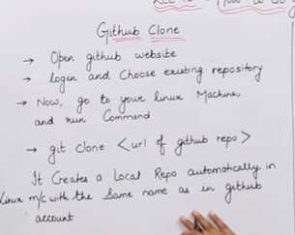

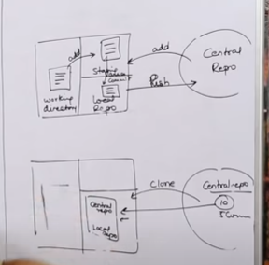

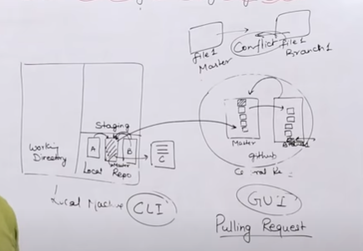

Ranjan@DESKTOP-K87NR6R MINGW64 ~/git-test (master)

$ ls

abc1 demof1 election ght revertfile

Ranjan@DESKTOP-K87NR6R MINGW64 ~/git-test (master)

$ git clone https://github.com/ranjan14567/Demo.git

Cloning into 'Demo'...

remote: Enumerating objects: 24, done.

remote: Counting objects: 100% (24/24), done.

remote: Compressing objects: 100% (14/14), done.

remote: Total 24 (delta 7), reused 9 (delta 3), pack-reused 0

Unpacking objects: 100% (24/24), done.

Ranjan@DESKTOP-K87NR6R MINGW64 ~/git-test (master)

$ ls

abc1 Demo/ demof1 election ght revertfile

Ranjan@DESKTOP-K87NR6R MINGW64 ~/git-test (master)

$ cd Demo

Ranjan@DESKTOP-K87NR6R MINGW64 ~/git-test/Demo (main)

$ ls

LICENSE new1 new3 rbc1 README.md xyz.txt

Ranjan@DESKTOP-K87NR6R MINGW64 ~/git-test/Demo (main)

$ touch filenew

Ranjan@DESKTOP-K87NR6R MINGW64 ~/git-test/Demo (main)

$ git add .

Ranjan@DESKTOP-K87NR6R MINGW64 ~/git-test/Demo (main)

$ git commit -m "new file commit on nov"

[main 0e6e773] new file commit on nov

1 file changed, 0 insertions(+), 0 deletions(-)

create mode 100644 filenew

Ranjan@DESKTOP-K87NR6R MINGW64 ~/git-test/Demo (main)

$ git push origin main

fatal: HttpRequestException encountered.

An error occurred while sending the request.

Username for 'https://github.com': ranjan14567

Counting objects: 2, done.

Delta compression using up to 4 threads.

Compressing objects: 100% (2/2), done.

Writing objects: 100% (2/2), 254 bytes | 0 bytes/s, done.

Total 2 (delta 1), reused 0 (delta 0)

remote: Resolving deltas: 100% (1/1), completed with 1 local object.

To https://github.com/ranjan14567/Demo.git

ba91dc6..0e6e773 main -> main

Ranjan@DESKTOP-K87NR6R MINGW64 ~/git-test/Demo (main)

Git Stashing: (Temporary Storage in Local repository)

--------------

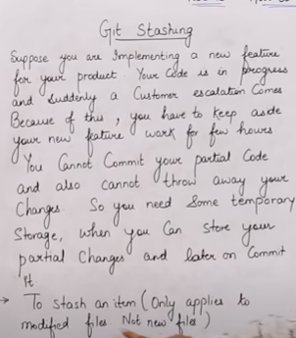

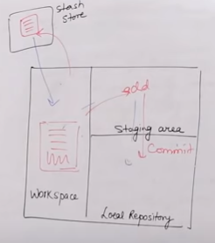

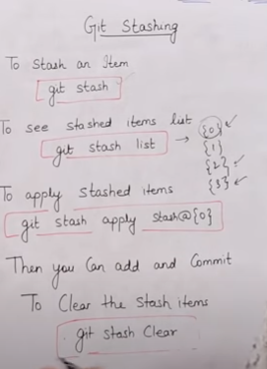

0 zero is the latest file

Ranjan@DESKTOP-K87NR6R MINGW64 ~/git-test (master)

$ touch demof1

Ranjan@DESKTOP-K87NR6R MINGW64 ~/git-test (master)

$ git add .

Ranjan@DESKTOP-K87NR6R MINGW64 ~/git-test (master)

$ git commit -m "demo file for stashing"

[master 92c24da] demo file for stashing

1 file changed, 0 insertions(+), 0 deletions(-)

create mode 100644 demof1

Ranjan@DESKTOP-K87NR6R MINGW64 ~/git-test (master)

$ vi demof1

Ranjan@DESKTOP-K87NR6R MINGW64 ~/git-test (master) //write a 2line code

$ cat demof1

1st code

2nd code

Ranjan@DESKTOP-K87NR6R MINGW64 ~/git-test (master) //type wrong command

$ git statsh

git: 'statsh' is not a git command. See 'git --help'.

Did you mean this?

stash

Ranjan@DESKTOP-K87NR6R MINGW64 ~/git-test (master)

$ git stash

warning: LF will be replaced by CRLF in demof1.

The file will have its original line endings in your working directory.

Saved working directory and index state WIP on master: 92c24da demo file for stashing

HEAD is now at 92c24da demo file for stashing

Ranjan@DESKTOP-K87NR6R MINGW64 ~/git-test (master) //After stash nothing in file

$ cat demof1

Ranjan@DESKTOP-K87NR6R MINGW64 ~/git-test (master)

$ git stash list

stash@{0}: WIP on master: 92c24da demo file for stashing

Ranjan@DESKTOP-K87NR6R MINGW64 ~/git-test (master)

$ vi demof1

Ranjan@DESKTOP-K87NR6R MINGW64 ~/git-test (master)

$ cat demof1

3rd code

Ranjan@DESKTOP-K87NR6R MINGW64 ~/git-test (master)

$ git stash

warning: LF will be replaced by CRLF in demof1.

The file will have its original line endings in your working directory.

Saved working directory and index state WIP on master: 92c24da demo file for stashing

HEAD is now at 92c24da demo file for stashing

Ranjan@DESKTOP-K87NR6R MINGW64 ~/git-test (master)

$ git stash list

stash@{0}: WIP on master: 92c24da demo file for stashing

stash@{1}: WIP on master: 92c24da demo file for stashing

Ranjan@DESKTOP-K87NR6R MINGW64 ~/git-test (master)

$ cat demof1

Ranjan@DESKTOP-K87NR6R MINGW64 ~/git-test (master)

$ git stash apply stash@{1}

On branch master

Changes not staged for commit:

(use "git add <file>..." to update what will be committed)

(use "git checkout -- <file>..." to discard changes in working directory)

modified: demof1

no changes added to commit (use "git add" and/or "git commit -a")

Ranjan@DESKTOP-K87NR6R MINGW64 ~/git-test (master)

$ cat demof1

1st code

2nd code

Ranjan@DESKTOP-K87NR6R MINGW64 ~/git-test (master)

$ git add .

Ranjan@DESKTOP-K87NR6R MINGW64 ~/git-test (master)

$ git commit -m "Initial code done"

[master e4953aa] Initial code done

1 file changed, 2 insertions(+)

Ranjan@DESKTOP-K87NR6R MINGW64 ~/git-test (master)

$ git stash apply stash@{0}

Auto-merging demof1

CONFLICT (content): Merge conflict in demof1

Ranjan@DESKTOP-K87NR6R MINGW64 ~/git-test (master)

$ vi demof1

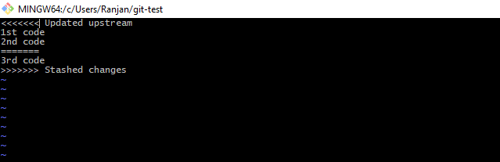

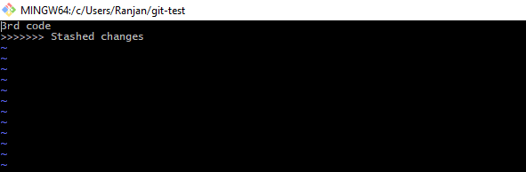

Ranjan@DESKTOP-K87NR6R MINGW64 ~/git-test (master)

$ git status

On branch master

Unmerged paths:

(use "git reset HEAD <file>..." to unstage)

(use "git add <file>..." to mark resolution)

both modified: demof1

no changes added to commit (use "git add" and/or "git commit -a")

Ranjan@DESKTOP-K87NR6R MINGW64 ~/git-test (master)

$ git add .

Ranjan@DESKTOP-K87NR6R MINGW64 ~/git-test (master)

$ git commit -m "second code done"

[master eb2b4cd] second code done

1 file changed, 2 insertions(+), 2 deletions(-)

Ranjan@DESKTOP-K87NR6R MINGW64 ~/git-test (master)

$ git status

On branch master

nothing to commit, working tree clean

Ranjan@DESKTOP-K87NR6R MINGW64 ~/git-test (master)

$ git log --oneline

eb2b4cd second code done

e4953aa Initial code done

92c24da demo file for stashing

3a8b9a3 resolve conflict

3fb03b4 trd commit with new conflict msg

177ca7d third commit with merge conflict

6850c8c 2nd commit

8366252 1st commit

Ranjan@DESKTOP-K87NR6R MINGW64 ~/git-test (master)

$ git stash list

stash@{0}: WIP on master: 92c24da demo file for stashing

stash@{1}: WIP on master: 92c24da demo file for stashing

Ranjan@DESKTOP-K87NR6R MINGW64 ~/git-test (master)

$ git stash clear

Ranjan@DESKTOP-K87NR6R MINGW64 ~/git-test (master)

$ git stash list

Ranjan@DESKTOP-K87NR6R MINGW64 ~/git-test (master)